PreSS RELEASE 2020

NEW BALI COLLECTION: GRAFF’S TAKE ON GOLD

The new BALI collection by GRAFF, the American company known worldwide for the quality and exclusivity of its bathroom products, offers a new version of the industrial chic style with the most contemporary designs.

Designed by G+Design Studio, Bali is a timeless collection that satisfies any type of furnishing project with wall-mounted fixtures, shower sets, and freestanding elements. These artful architectural pieces are born out of this concept: a stylistic reimagination of existing lines in a resolutely modern way.

All the components of the BALI collection are characterized by a rhythmic aesthetic made up of intricate geometries and enriched by stylistic details. All the washbasins, bidets, bathtubs, and shower articles are made from an internally hollowed block of solid brass and stand out for their unique structure and fine industrial design. The classic architecture of the body-spout-lever is redefined in favour of a harmonic tubular shape that harks back to old water pumps in the 1800’s.

The available finishes are in galvanic, organic, powder and gold versions as well as in PVD—Physical Vapor Deposition—an innovative finishing process that leads to a very high level of surface hardness together with an unparalleled resistance to atmospheric agents and cleaning detergents.

The 24K polished gold version of BALI expresses the utmost form of elegance and refinement. 24K gold plating is applied to a nickel-plated brass surface, and the result is an extremely precious surface with a very rich colour.

Produced in brass with a very low nickel and lead content, BALI faucets are made in compliance with the regulations for drinking water and therefore based on the most restrictive criteria required for the protection of health and the environment.

AVAILABLE FINISHES

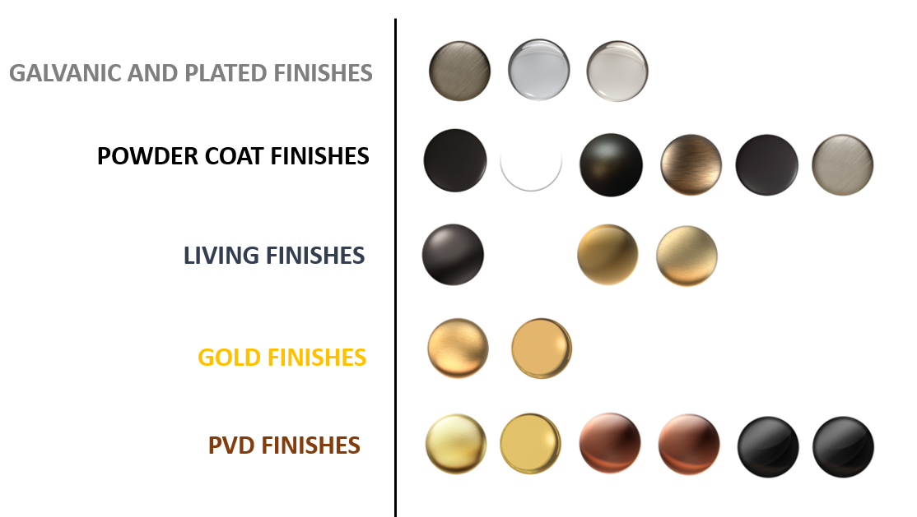

Collection name: BALI
Finish name: AU, 24K Polished Gold
Design: G+Design Studio

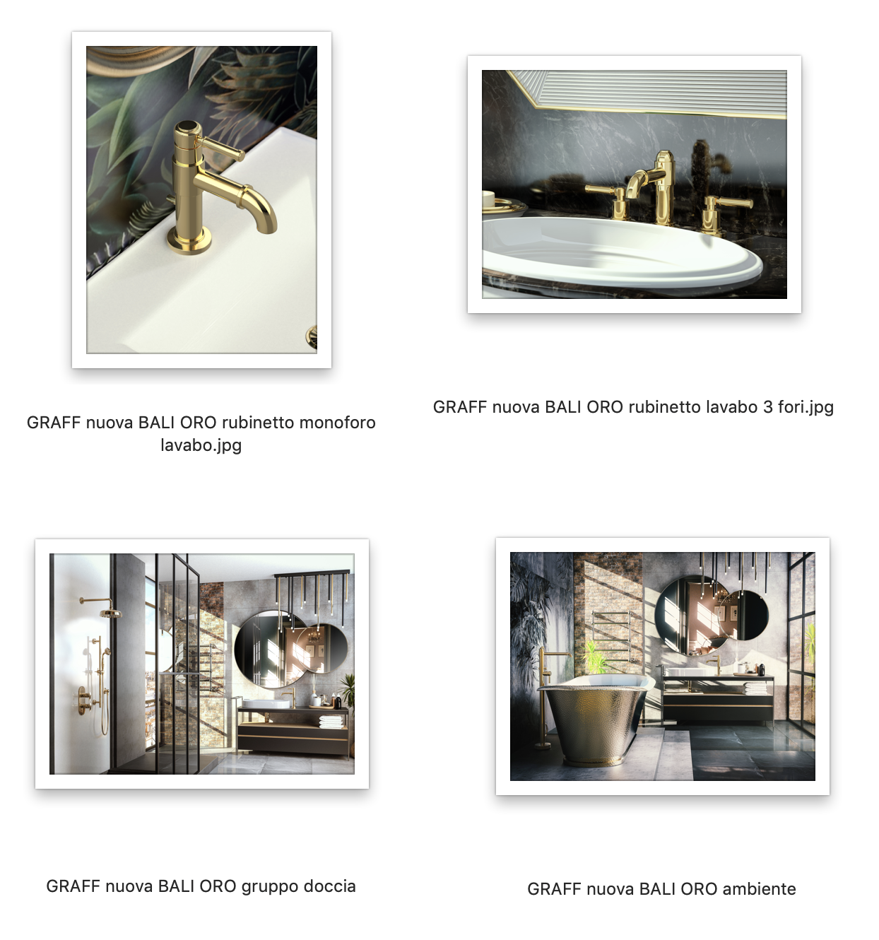

GRAFF EUROPE
Via Aretina 159, 50136 Florence - ITALY
Tel: +39 055 9332115,
fax: +39 055 9332116
info@graff-designs.com
www.graff-designs.com

UFFICIO STAMPA
tac comunic@zione milano|genova
tel +39 02 48517618 | 0185 351616
press@taconline.it | www.taconline.it

